Assembly Instructions

# Pack Contents

|  |  |
| --- | --- |
| 1x Arduino  1x Motor shield  1x 9v battery clip  1x 6xAA battery holder  6x AA Batteries  1x Base plate  2x Motor mounts  2x Rear axle mounts  2x Sensor holders  2x Geared motors  1x Axle shaft | 3x Wheels  1x Long zip tie  8x Short zip ties  10x 20mm M3 bolts  4x 30mm M3 bolts  17x M3 nuts  1x Senor PCB  5x IR LEDs  5x IR Photodiodes  5x 330 Ohm resistors (Orange Orange Brown)  5x 10k Ohm resistors (Brown Black Red) |

In addition to this you will need four ~20cm lengths of stranded wire for the motors and seven ~20cm lengths of solid core wire for the sensor PCB.

1. Solder stranded wire onto the motors. The wires should be around 20cm long. If in doubt, cut the wire longer, you can always cut it down later.
2. Attach the motor to the mount using the (longer) 30mm screws:

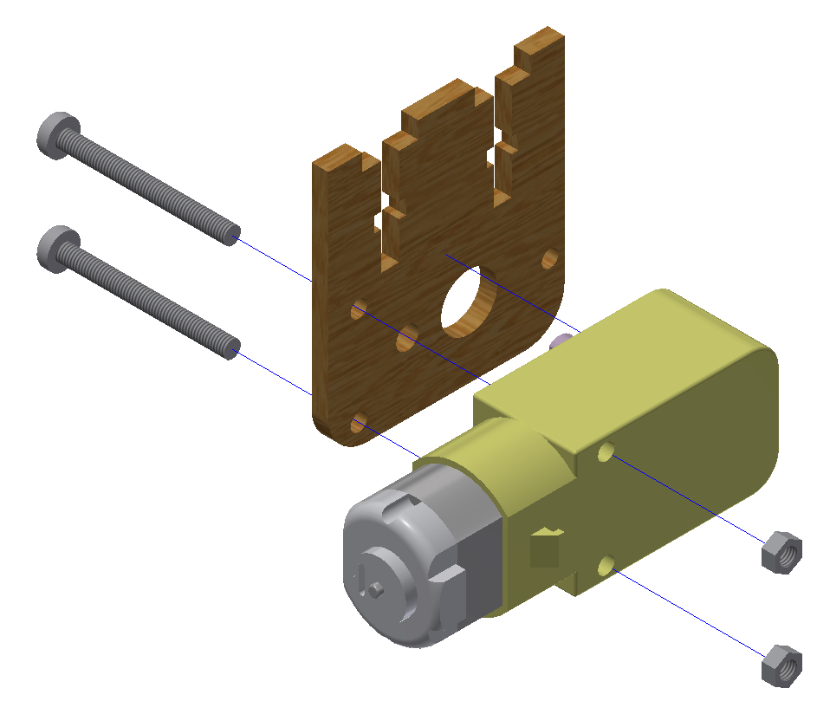

Repeat this for the second motor but this time mirrored. The end result should look like this:

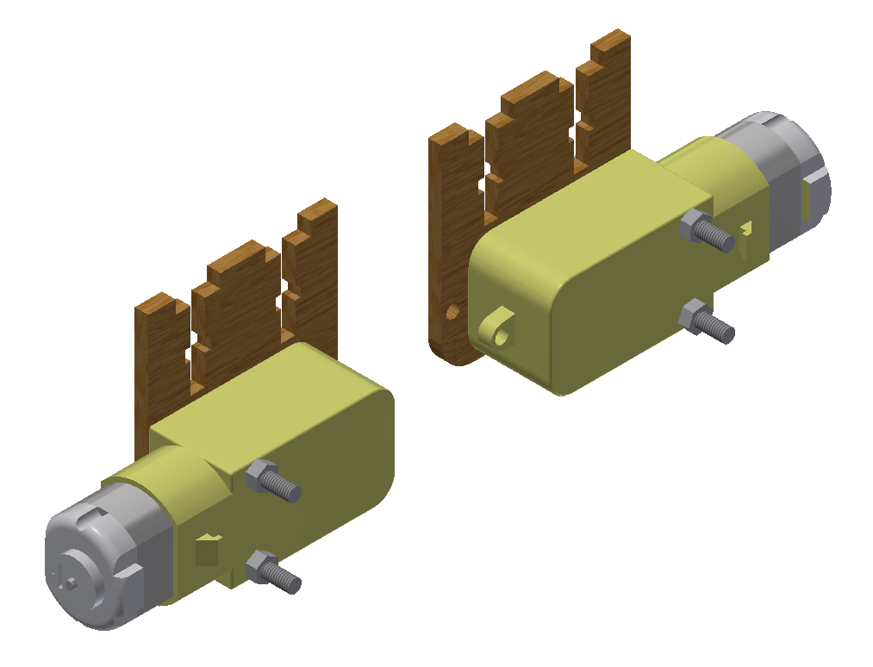

1. Attach the motor and axle mounts to the base plate using the 20mm screws:

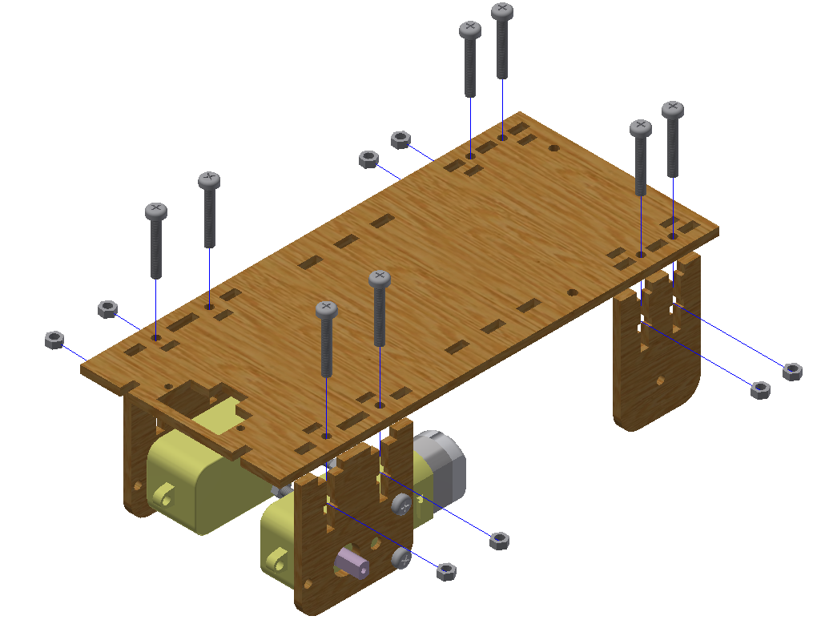

**NOTE**: **Do not over tighten the screws**. Acrylic is a very brittle plastic and will crack easily if too much force is applied. Don’t worry if the mounts have a little bit of movement in them, this will not affect the robot’s functionality.

1. Mount the Arduino to the base plate using 2 nuts as a spacer. Note that the front screw goes from the bottom and the back screw from the top:

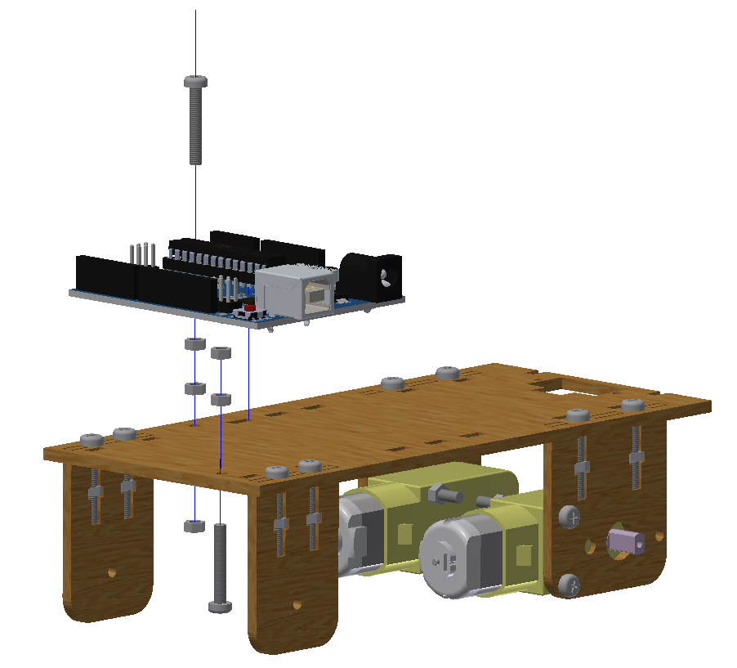

1. Apply electrical tape around the rear wheel (the one with the smaller hole). This is so that the back wheel can easily slide around when the robot turns.
2. Attach the wheels to the robot:

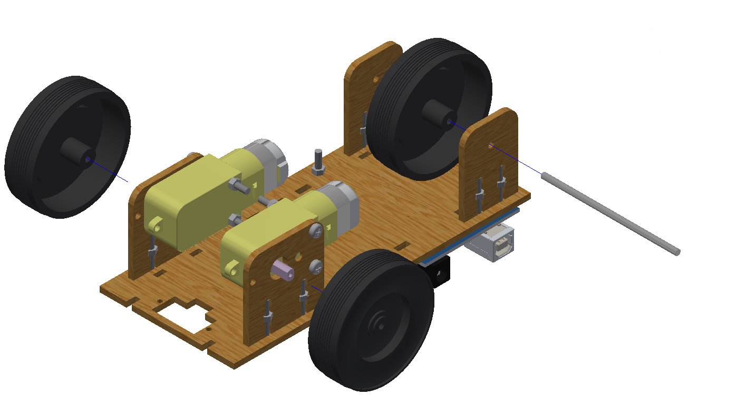

1. You will find that the rear axle easily slips out of its mounts. To fix this simply wrap a little bit of electrical tape around the axle so it cannot slide around.
2. To prevent the front wheels from falling off, use the short zip ties to tighten the wheels onto the motors. If you find that the wheels still fall off, remove the wheels, place hot glue into the hole and reattach them.
3. Plug in the motor shield and wire up the two motors: 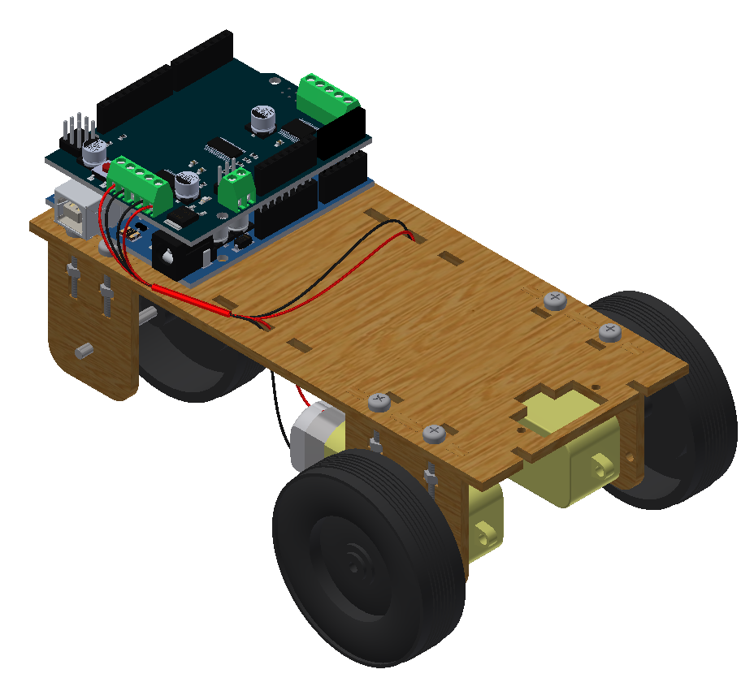
4. Attach Sensor holders:

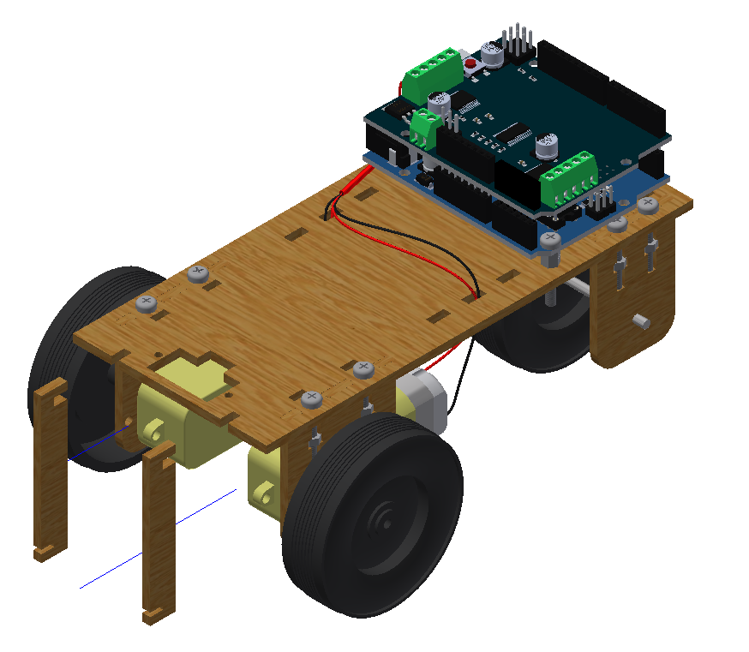

1. If the sensor holders a loose, use small zip ties to attach them to the motors.
2. Attach the senor PCB:

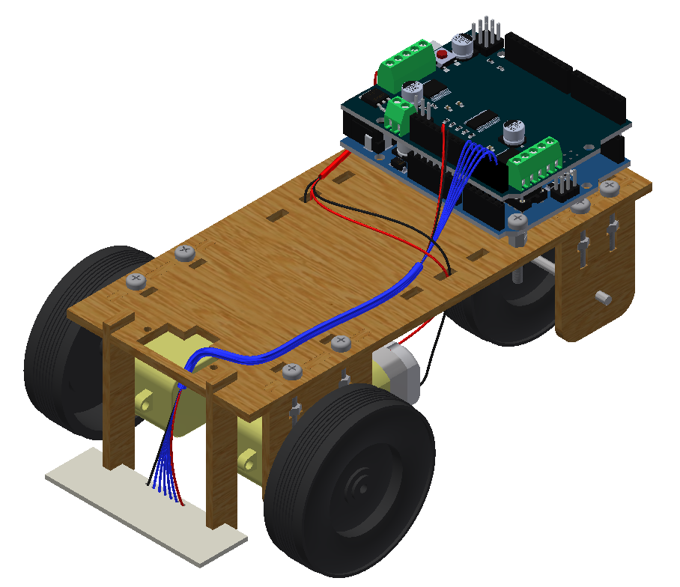

A pinout for the sensor PCB can be found in the soldering instructions. Just match that to the labels on the side of the Arduino.

1. Attach the battery pack (with the 6 AA batteries inserted) using the two large zip ties. One will need to go in from the top and the other from the bottom before you join them together:

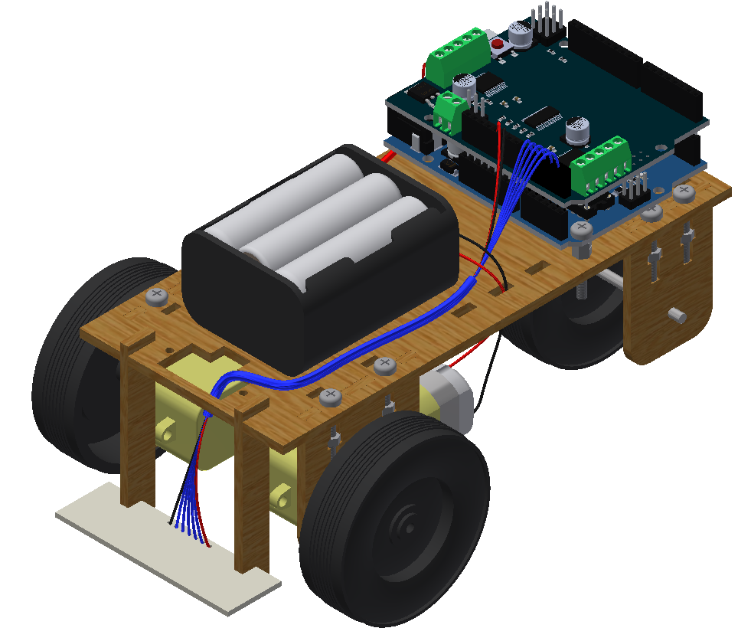

1. Connect the battery pack to the motor shield using the 9v battery connector. The red wire goes to the M+ terminal and the black wire goes to the GND terminal.